Subject: Stage 2 Digital Technologies

Task: Assessment task 4/ Web store

Student: George Gadalla

SACE NO: 591604J



Teacher: Mr Papazoglou

# Introduction

**The scenario**: I am web application development specialist who has been assigned to create the front end to a clothing store called Shirts & Pants Ltd. In the initial phase, this Web portal allows customers to match shirts and pants only.

This will be completed through the use of Komodo edit 9 and CSS stylesheets, HTML and JavaScript. The final objective is to have the HTML and CSS be complementary to my screen which is the average size for a laptop and have it visually appealing and functional to the user.

# Design ideas

I looked through the internet to common websites known for selling clothes and annotated them and indicated the parts that inspired me and the concepts I was going to use

**Idea 1 (Myer)**

**Header**: I like the appearance of the header and the classic colour scheme between the black and the white. The title Is positioned in the centre so the brand name is clear.

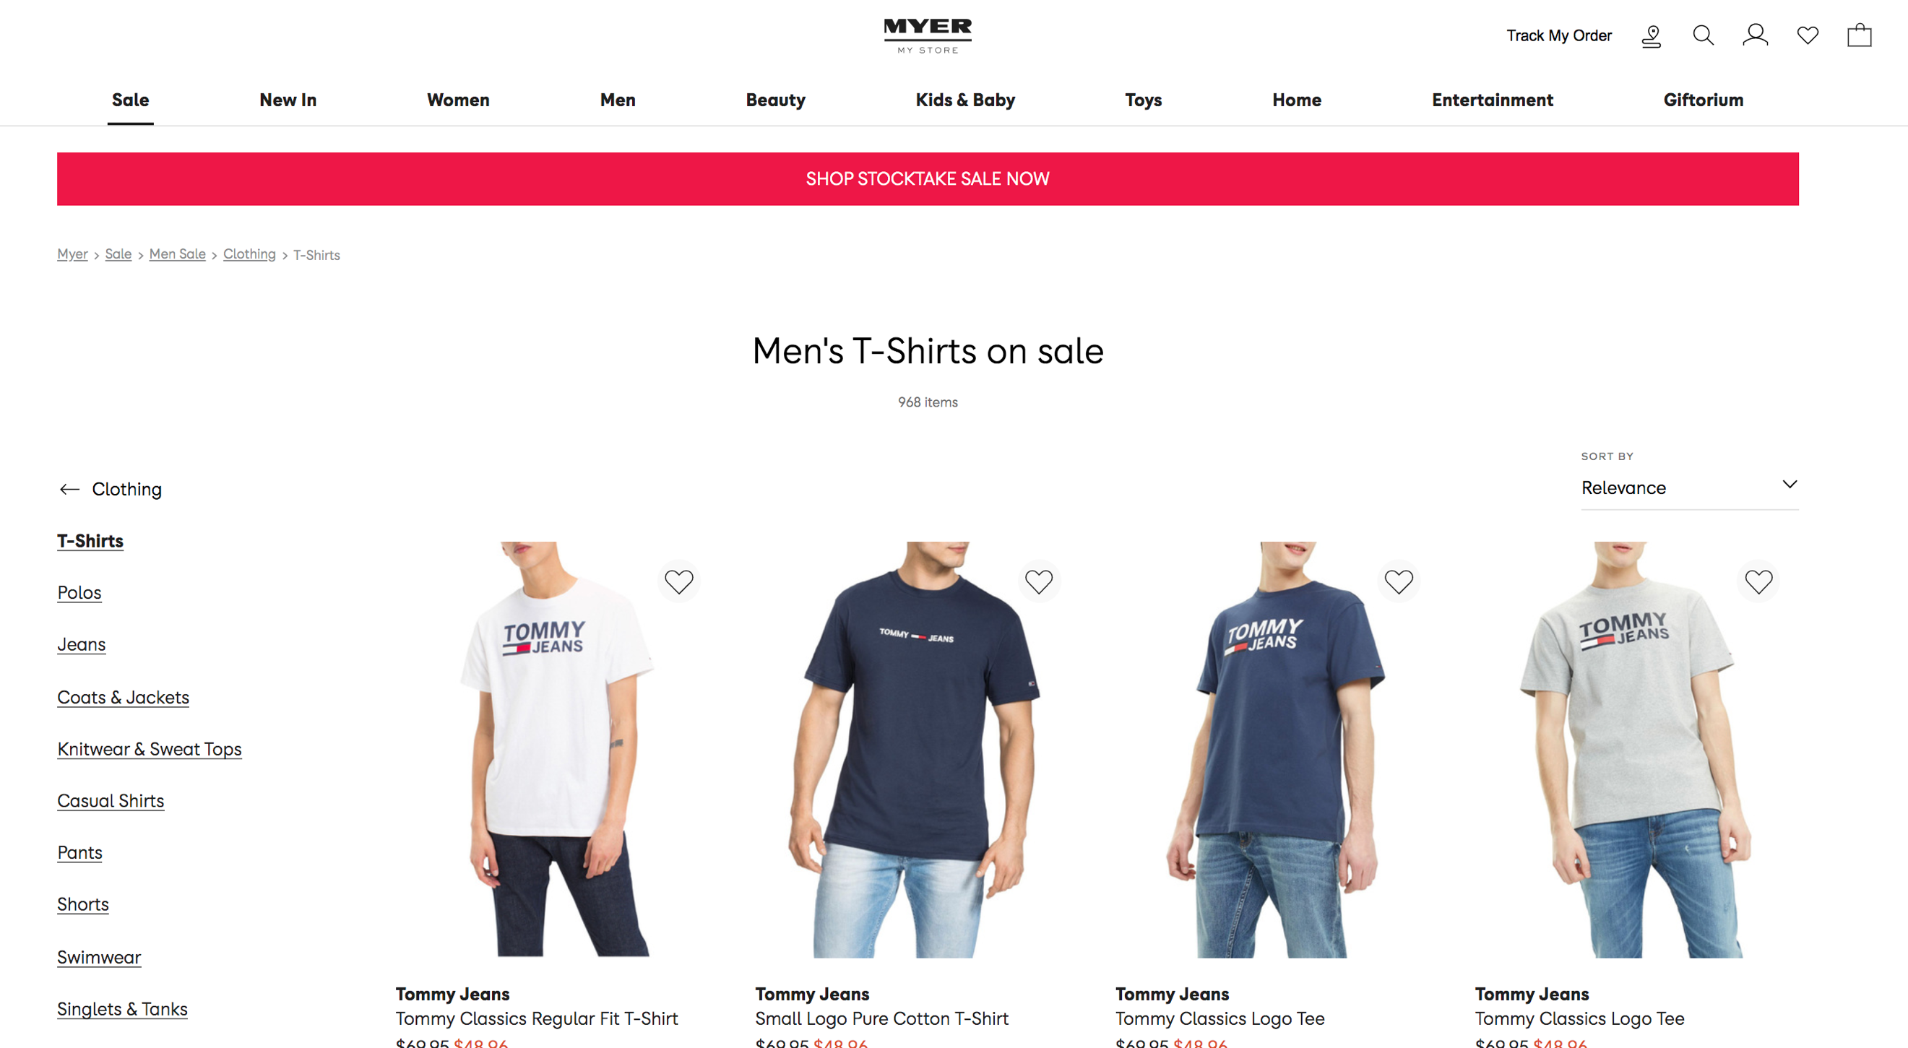

**Images**: the images are relevant of to the website, they display the product that the user could buy if they chose it

**Button**: The button design was practical and worked well and responsive, the colour scheme matches the theme of the website and the button font is simple and neat.

**Price tag:** the price is shown below the image that displays how much the item costs

**Idea 2 (Tommy Hilfiger)**

**Header:** The header is similar to the last one and shows the company logo in the centre

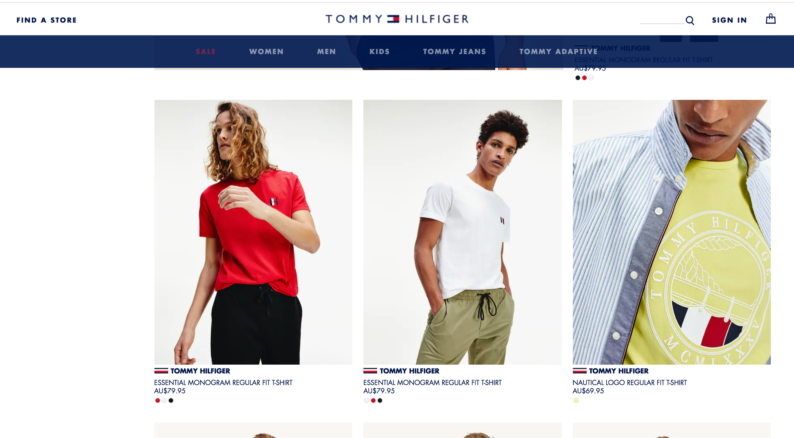

**Colours:** The colour scheme is simple and is relevant to the companies logo

**Images:** The images are relevant and show the product that the user could buy

**Logo:** The logo is centred similar to the last websites and the brand name is clear

# Mark-up design

**Header:** The header contains the company logo and is simple with a black colour

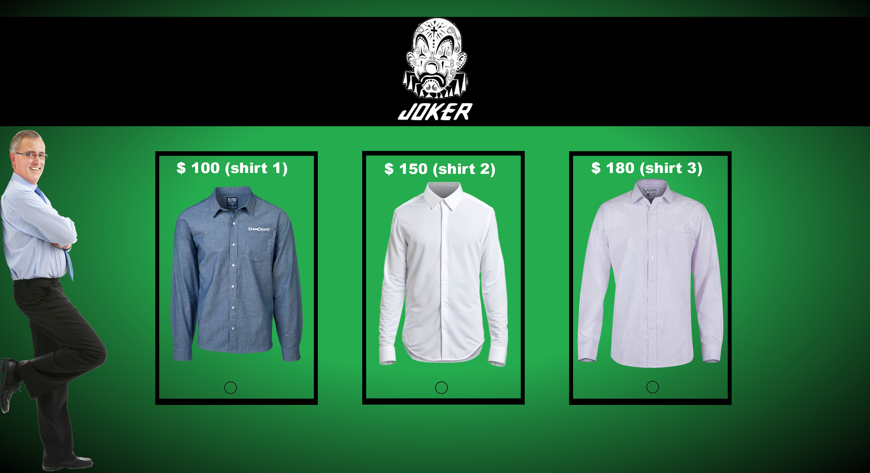

**Colour scheme:** The colour scheme is simple blend of green, black and white (*note it could change)

**Images:** The images shows the user what product they will be buying if they choose the option

# Instructions to code

My design will include 2 separate pages, when the user presses on the link they will be firstly be redirected to a landing page with a button asking them if they would like to shop. Accompanied by a background image of some clothes and the logo somewhere in the corners. If the user presses the button on the landing page they will be sent into the second page with the images of the pants and shirts with radio buttons for the user to choose if they want to buy pants and shirts or only one item. There will also be a dropdown menu that will ask the user for what type of shipping they would like and will display the price of each option

Using JavaScript a switch statement can be created for cases depending on what the user chooses to buy. There will be multiple fragments of JavaScript code that will do other actions, I want to have the images of the clothes and the radio button on one ‘tile’ appear through on scroll animations the page will be large in height to have the clothes spaced apart with the final pay option at the bottom of the page. The last part of the code using JavaScript will be creating the switch statement to calculate the total price (including $40 administration fee) that the user will have to pay. This is all summarised by **figure 1**.

**Figure 1**: A structure chart showing the process of the webpage(s)

3

Buying page

1

If x = Case

2

Price = $40 + “Pant 3” + “Shirt 3”

Price = $40 + “Pant 2” + “Shirt 2”

Price = $40 + “Pant 1 ” + “Shirt 1”

Landing page

# Code analyses

**Buying code**

**AOS**

<div class="div" data-aos="fade-left" data-aos-duration="800" data-aos-once="true">

<fieldset style="width:275px; position: absolute; border: none; ">

<img src="images/ws.png"><br>

<input type="radio" id="shirt" name="type" value="1">

<label for="male">Shirt 1 ($100)</label><br>

</fieldset>

</div>

**Scroll down on click**

function scrollDown(){ // Function scrolls page down

$('html, body').animate({scrollTop:2000},'100'); // Scrolls to the specified px in 100ms

}

# Final Product

**Logo:** The logo is in the top right corner with the brand name clear

**Title:** The name of the brand is centred and clear to the user

**Background image:** the image shows a man and a women wearing clothing that promotes the brand

**Button:** the button says “get started” and is animated to quickly transition from blue to white when the mouse is over

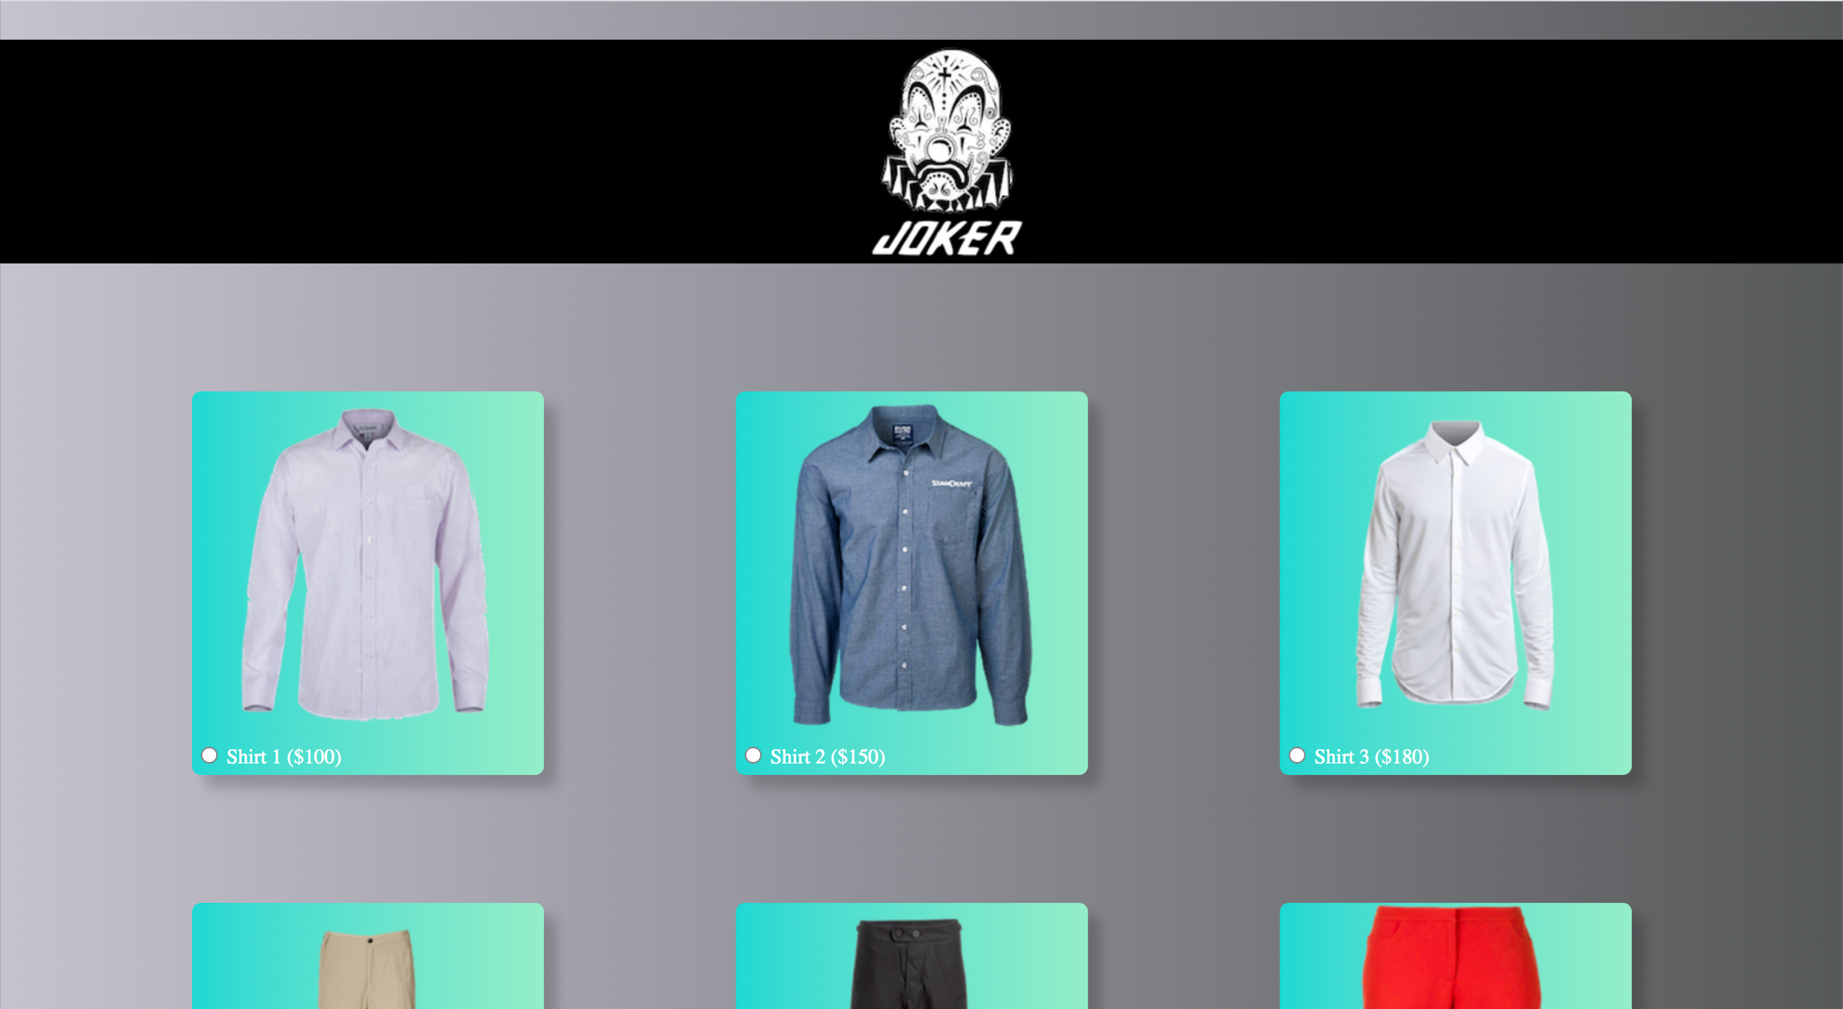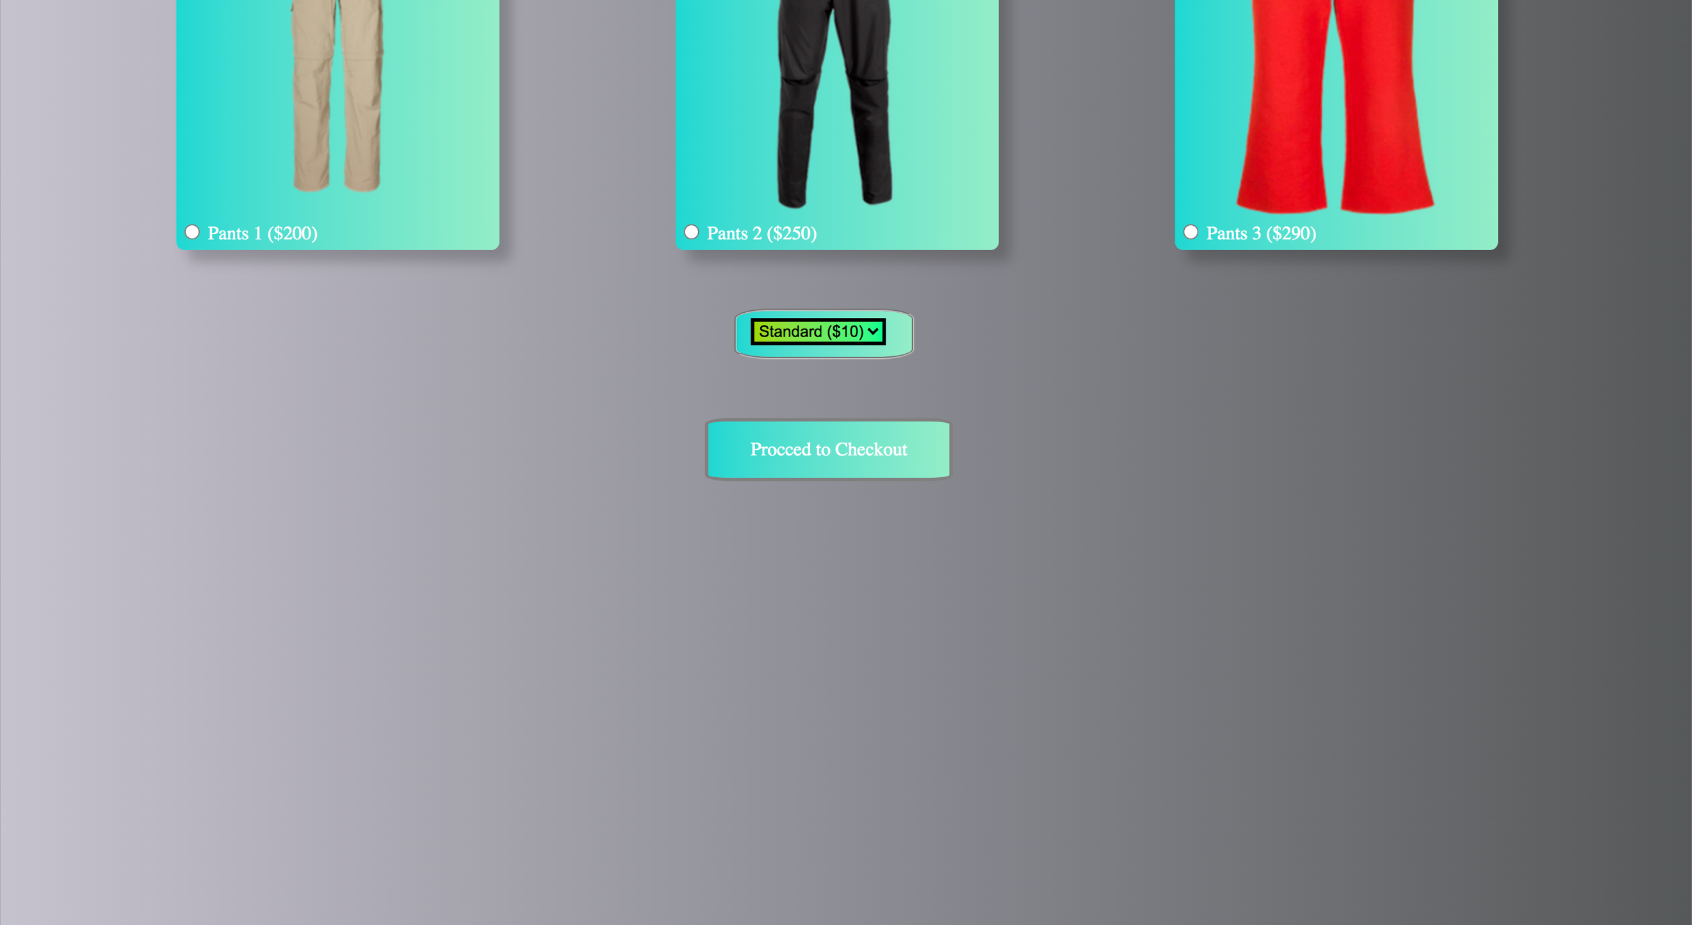

**Logo:**

**Radio button:**

**Button:**

**Shipping:**

**Images:**

**Title:**

# Video

# Survey

# Improvements and Conclusion